Final report for the UIDE

# 1.Website name

**ABC News Site.**

Focus on the news in media type.

The version released notes-------

To create a new version app designed for the media company.

The app must satisfy the requirements for the basic function.

And the updated version can improve the User Experience and bring more positive feedback.

# 2.Group No & member’s ID

|  |  |  |
| --- | --- | --- |
| Group 23 | 16301070 | 梁洪铭 |
| 16301079 | 严建伟 |
| 16301061 | 陈巍 |
| 16301063 | 顾堃略 |

# 3. The Single Statement of Need (SSON)

The “ ” web is like a window open for you to learn about the newest happening around China or the whole world. Also it would provide you the chances of making a contact with the world. Watching, learning and feeling, you will get a complete experience when browsing the news.

# 4. Our Users

|  |  |
| --- | --- |
| **User Group** | **User behavior and requirements** |
| Students | Apply to watch funny stuff to relax. And search for some valuable videos to learn something new. |
| The elder | Use the site as a tool of knowing the world and get the newest news around the world which cannot get from the newspaper. |
| Office worker | They get to pick up the newest news which can catch their interest in a limited time during their office work. |
| Housewife | Pick up the news and choose what they like just to relax. And find something to kill time. |
| Young lady | They have something follow their interests, so mostly they focus on the news or videos they are interested in. |
| Media authors or editors | They offer to collect some related article and gain inspiration for the article writing. The sources news and media material bring a lot ideas. |
| Young kids | They are curious about what the news are like around the world, they have a strong interest in the fabulous news around. |

# 5. Requirements

## Functional Requirements

What the system should do – operations it must support.

(Open account, display drive size, schedule delivery.)

1. Show the newest news and user can browse the news display window. And the related news pictures are shown in rotation, visitors can also choose what they want.
2. Visitors or Users can search the news what they want to see by using the search box. By searching the key words system would lead them to the pages they want.
3. Visitors or Users can switch the font size and the language version of the article to improve their reading experience by clicking different particular buttons.
4. Users can subscribe the channel they are interested in, and follow the publisher or the authors they like.
5. Users have the choices to share the news article or video to the other social website or app.
6. Users can see all the collection of his favorite news, articles, or video news. And have a whole view of all the publisher and tunnels they have subscribed.
7. Users can register and log in to enjoy his customized content in the home page, and see through all the news recommended by the system.
8. Users can give comments on the news or articles to communicate with the other users in the web site.

## Non-Functional Requirements

Constraints on the system and the development process.

1. **Usability Aspect**

Visitors can easily find the helping page. And the search box should be emphasized so as to find it easily.

80% users can find what they want to see in less than half minute(30 seconds) through the search bar item.

The number of the menu navigation-bar should be less than 5. Or the navigation would make the user hard to find where to go.

Provide data backup and recovery functions to enable timely recovery of data.

etc…

1. **International Aspect**

Language support should be more than 3 kinds at least.

Font size ranges from 1x to 5x.

Dates and times format should be like the (2018-12-14). As the Chinese version of recording the dates.

Etc…

1. **Performance/Reliability Aspect**

First for speed, the response time for the website should be less time 3 seconds in general situation. The search result should be loaded in 2seconds.

Then the capacity support for user should be as 10 thousand and can support the GB-level data. The database capacity should be no more than 1000GB.

Etc…

1. **Legal Aspect (The safety and the security)**

The authentication should be controlled strictly, user can only access the contents within their permissions.

Different user may have different permissions. And our web site should provide reliable authentication management, under the premise of verifying user rights. So the data consistency can be satisfied.

We may have VIP users and the normal users (two kinds.)

Etc..

1. **Development Aspect**

The coding structure should be followed tightly so that the modification due to the specific function can be done easily.

# 6. Personas

name: Jessica

Age: 25

Gender: Female

Employment: White Collar (works in a big Internet company)

Marriage: Single.

Education: College

**Pain Point**:

Fed up with reading too many words, she prefer something described easily and some media resources from news.

The recommended stuff is hard to find.

Hate to do so many choices, click too much would make her annoyed.

**Behaviors**:

Use the app to browse some newly posted news during break time at work every day.

She doesn’t prefer to find some category by herself, she just follow the recommended.

Glance over the recommended items from the web, click some funny news and roughly browse the summary of the news to find something with media resources.

**Goals:**

Get a brief understanding of what happened around the world in a short time during work break.

Find what is the popular news on that day, and follow some interesting publishers.

Prefer the media source rather than the text news.

**Scenario**

YaYa quickly finished her work on the morning, it has been a long time since she could have a rest during the work. She decided to find something interesting in the news web page to kill time actually. She get to the home page of the news site, various kinds of news jumped into her eyes, absolutely she got no idea about what things to see. So she keeps finding the popular news shown in the list. Finally she got something funny, and she wants more. But things get worse that she couldn’t directly see the related videos or news right after the videos finished. Sadly she had to get back again to the home page again for the related news.

Surely she didn’t get so much time for searching on her own, she need to get back work.

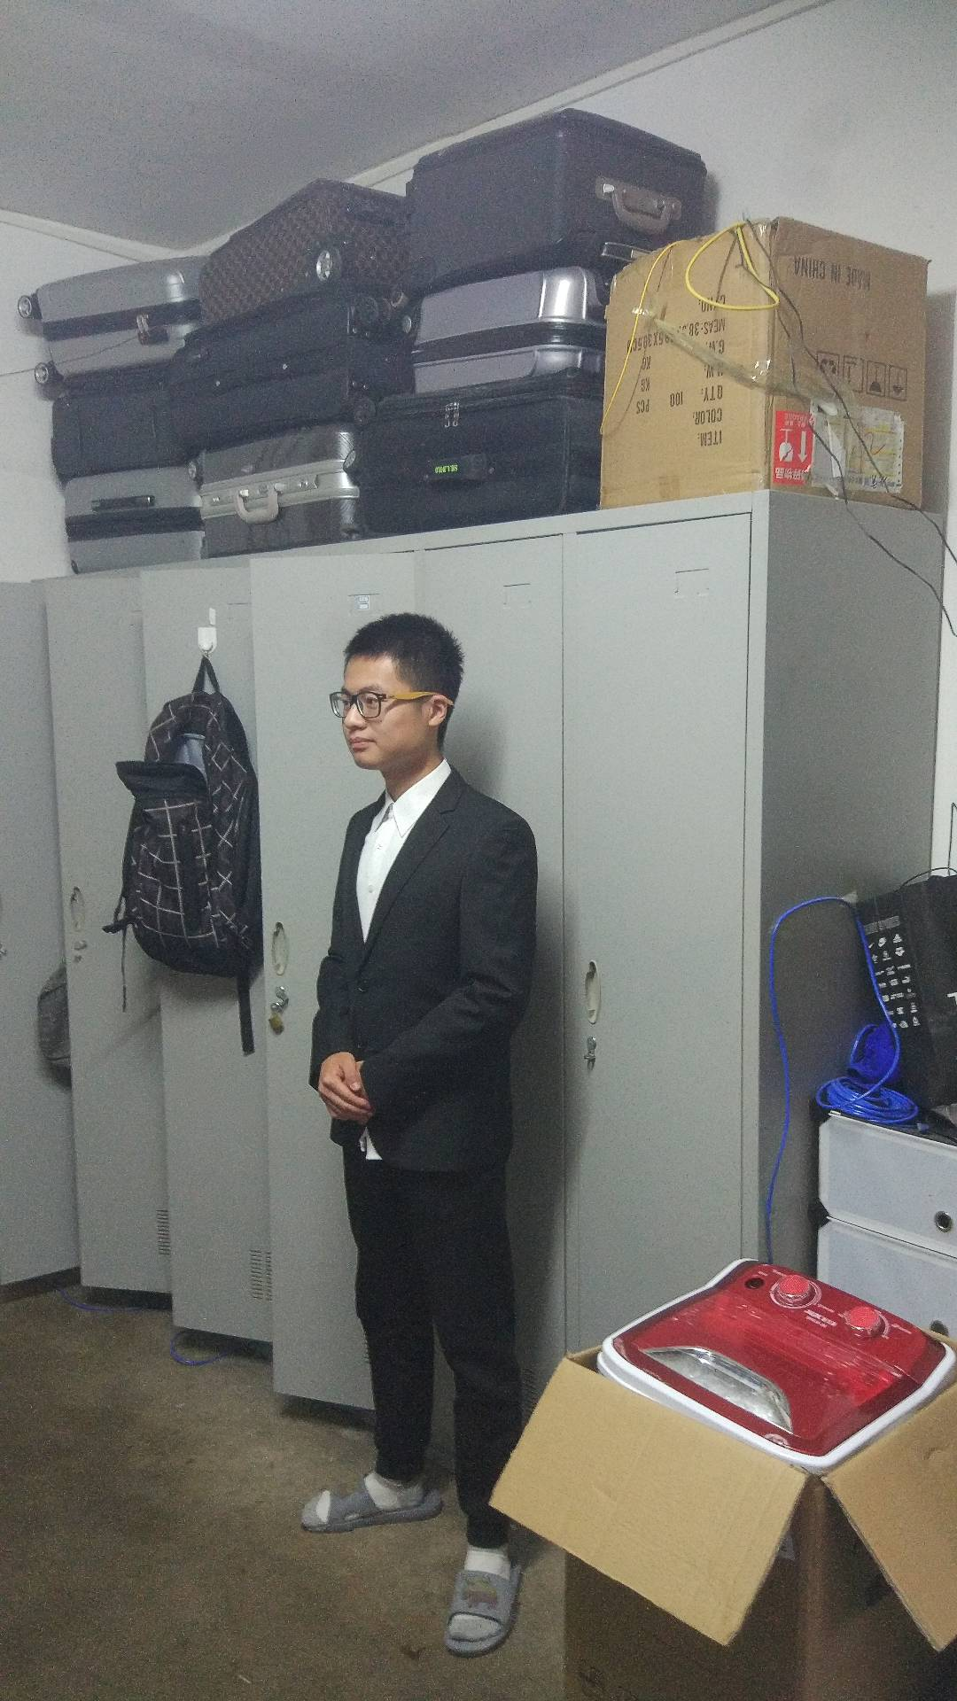 Name: LongWei

Age: 21

Gender: male

Employment: College Students

Still learning in university, major in Software Engineering. He likes thinking and has a gift on designing, also a strong programming skill. He loves game and cares about the world-wide news.

**Behaviors:**

Before going to class or after school, he usually get to the pages for more news.

Firstly he checks out the latest news in the world, then click it for details. When he gets the news he prefers, he would search or collect all the details of the news.

He would think a lot, and he need a place to post his comments and discuss with the other new friends.

**Goals:**

Collect the news world-wide and see the details.

Publish his thought and post the comment in the website to communicate with the others.

**Pain point:**

The news were described not detailed enough make him doubt.

Hate something complicated, the pressure in the school makes him no patience to focus what he doesn’t like.

Hate some news’ video are kept in too long time. He want to get detailed info in limit time.

**Scenario:**

During the break time in the school day, Long tried to get through the news web so as to get some information for the speech and presentation for the English class. He had to find resource both in text and media. However he got annoyed that the details are divided into so many parts in which he could not have a whole view about what was going. Moreover, he could not read the news text details while watching the video at the same time. The information is not concentrated enough，Mr. Long finally logged out.

Name: Yan Jian

Age: 26

Gender: male

Employment: Singer

Education: Doctor

**Pain Point**:

The function of subscription is very poor so that he can’t see what he likes very well. Besides, the newest thing can’t be post up soon. No search function is also awful. Even he wants to search his news manually, no way! How could anyone remember the number of the news?

**Behaviors:**

He is so narcissistic and capable that he wants to see his own news. Every day, if only he has leisure time, Twitter, Ins, Television and the Internet, all of these things are what he likes. Besides, he has a lot of friends in the entertainment circle and he always plays with his friends.

**Goals:**

Use this web App to get some information, mainly about himself and see how the journalists and the publishers have a comment on his activities. Besides, he likes Many outdoor activities such as basketball, mountain climbing and so on. He wants to watch some new information about the sports which he likes very much and he doesn’t much care about anything else.

**Scenario:**

One day, Doctor Yan gets up early as well. He has to get ready for a vocal concert. As usual, he turns on the television, listening to the news and brushing his teeth at the same time. Last night, there was a birthday for him in Beverley Hills, so he invited many celebrities. It was a huge party, thus a lot of journalists came to see. Sadly, he just see nothing about him, but he is not upset a little bit. After eating lunch, he can’t see as well! He is very angry but there is nothing he can do because the website even haven’t got a search bar. With helpless, he just wants to use the function called subscription to see something he likes. And the result is absolutely, no! He swears that he won’t use this application again.



Name: Laozhao

Age: 60-80

Gender: male

Employment: individual household

Education: College

**Pain Point**:

He finds that it’s hard to search information he want. There are so many buttons that he can’t differentiate them and affirm the functions they have. It’s hard for him to use the UI without any direction.

**Behaviors**:

He wants to find something interesting when he is leisure. So he found our website and registered an account. He search for the latest news and click for the detail which attract him. Then he discusses with others and gives his opinion. After that, he can talk to his families to learn more things.

**Goals:**

He want to count his thumbs and find interesting news. By the way, he can learn many fashionable knowledge so that he won’t become awkward when he talks and stay with families.

**Scenario**

When he was free during his working time, he get through the news web so as to get some information for fun. He finds the detail then read the comments that was published by others. When he finds the incorrect comments, he reply the user who publish the comments and even discuss with other people about this problem. By the way, he can get acquainted with different people. At the same time, he was waiting for the next business.

# 7. Problem Scenario

Mr. Long (the college student) wanted to collect a full integration of news info during these days, so that he could make a complete speech in the English class.

But confronted with the collection problem, Long cannot get all resources he needs within one page. Also the related news should be shown beside the news, but he could not find any, so he had to use the search box by searching the key words.

Sometimes the video news is spoken too fast, and some even are in English. Long actually cannot follow probably, and he needs a script part to help him understand what was gonging on. And he also try to get the English speaking news to slow down a little bit so that he could follow the news.

Moreover, Long tries to collect the data materials for the study but he could not find the history of his browsing. He can not get back to what he has been watched, so he only has to keep the pages of news which made his browser suffered huge pressure.

# 8. Activity Scenario

When Mr. Long first access to the site, he found that he should register account and log in to get a customized service from the news site.

Then after he has logged in, he was directed to the home page again, which includes the history record, the customized contents and some popular news around the world.

The navigation window for the popular news is huge enough so that he could focus on the latest news easily.

After choosing one news, we may come to a new page which showed both the media resources and the article. The video news is placed top, then Long tried to see the details text, he scrolls the page, and the video keeps at the top. Below the media player we’ve got several items for the related news listed. So Mr. Long feel comfortable that he got the recommended news easily so that he would not need to search the key words again to get more.

After watching some part of the video, Mr. Long decides to focus more on the text descriptions. So he spotted that a pull-back button was put at top to make the video player pull up.

Mr. Long gets satisfied with the news experience, so he click the likes , and the Follow button to follow the publisher and subscribe the tunnel he gets interested in. When he chooses the Profile page, he may find all the articles and media resources he marks or collects. The favorites and history records of his account are shown briefly.

# 9. Use Cases

Use cases: Update for complexity

Requirement Use Cases

|  |  |
| --- | --- |
| **Requirements** | **Use cases** |
| The user will be able to watch the news video. | Watch the video news. (User)  Publish the news (Publisher) |
| The user will be able to subscribe the  publishers to the favorite collections. | Subscribe the publisher (User)  Publish the news (Publisher)  Update the collections(Web) |
| The user will be able to view the  contents of the collections. | View favorite(User) |
| The user will be able to search the  specific content through key words. | Search the key words (User) |
| The user will be able to choose  the version of language. | Choose Language (User)  Update Settings(Web system) |
| The news will be updated. | Update the news.(Publisher) |
|  |  |

The USE CASES: RESULTING DIAGRAM

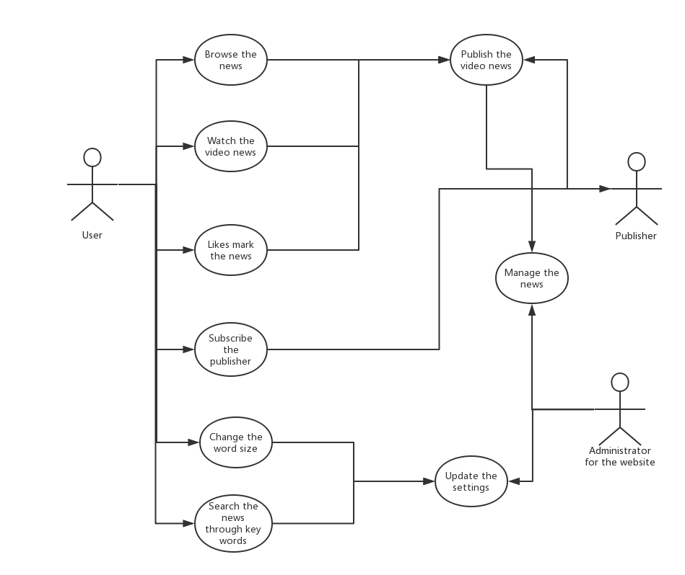

Actually I am sorry that we don’t know whether we could put a administrator character for the user model.

# 10. Prototype

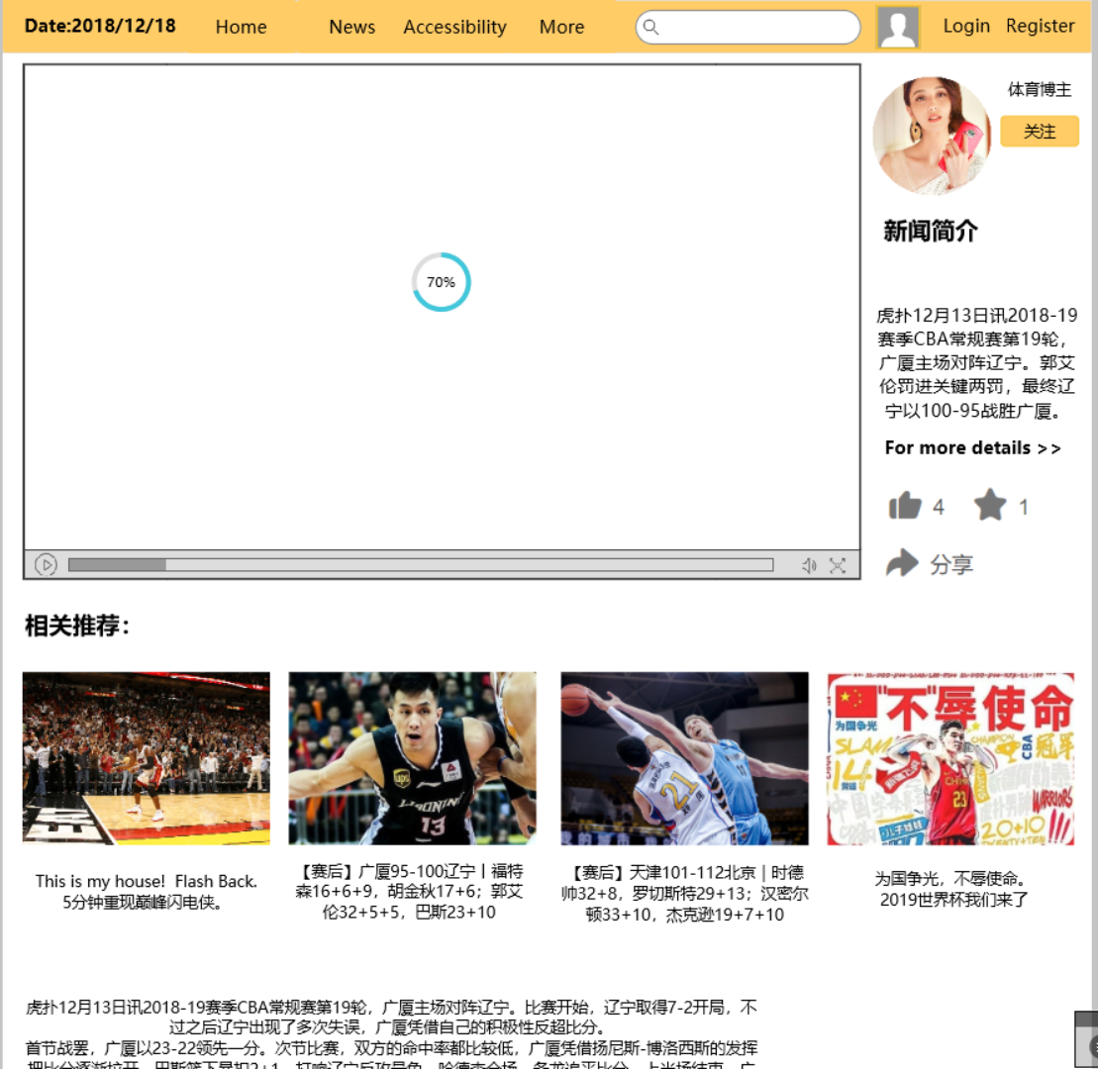

This is the page for playing the video news.

We put the all the information about this news on the right, including the publisher’s information also the summary of the news.

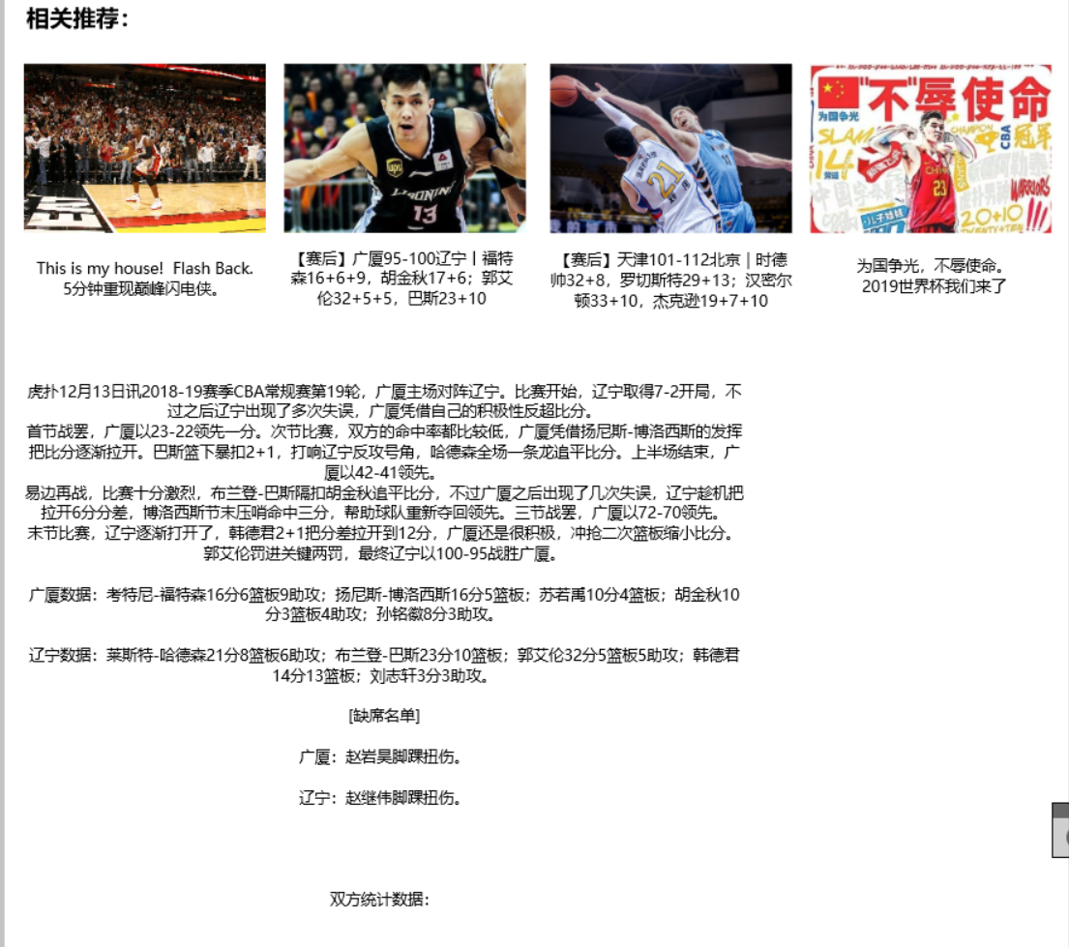

The details about the news and some related media news are also provided in the layout.

User can choose what they want to see.

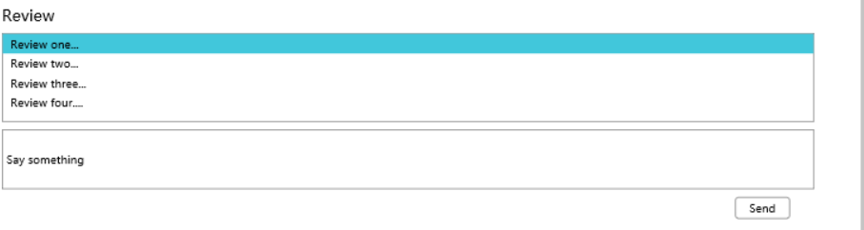

At the bottom we also have the comment area for the user to post the comments.

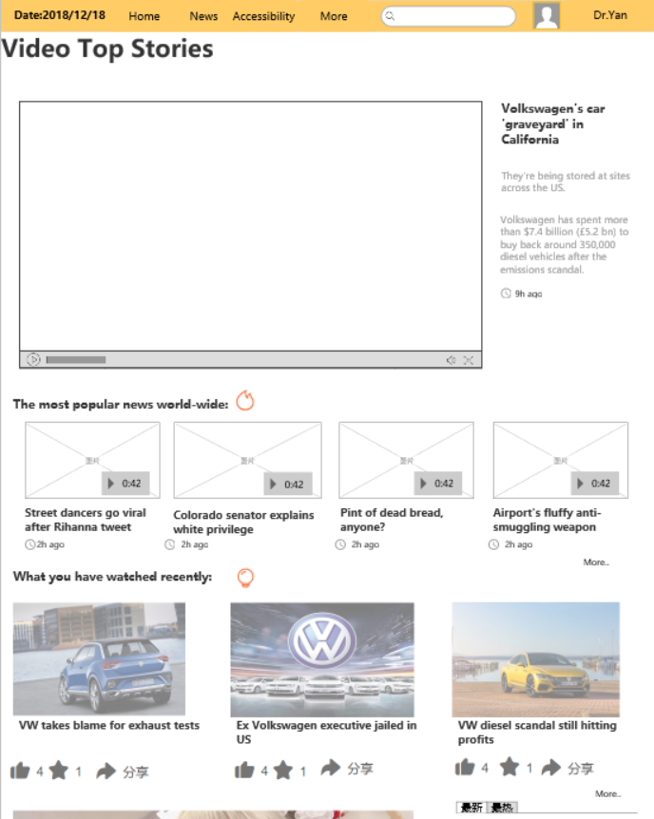

This is the home page for the news site.

At top we have the hottest news. And we also put some popular news and the news you have recently viewed.

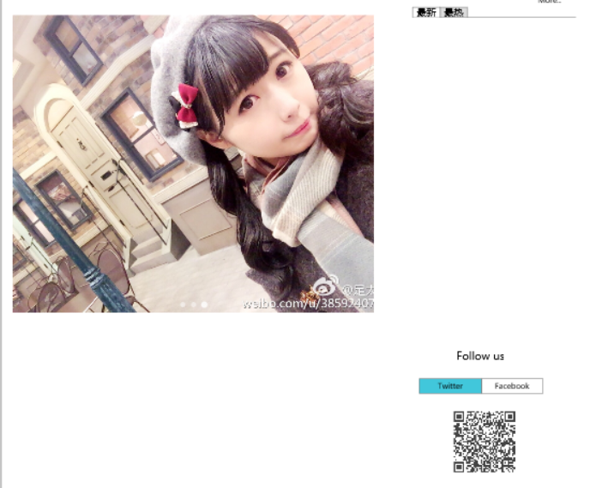

At the bottom we have the rotation page, to show some advertisement stuff etc.

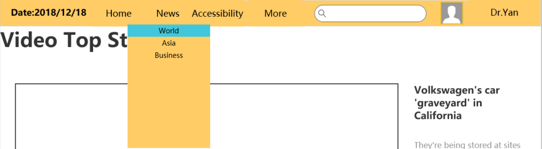

Then for the navigation bar on top, we could choose the world news or some other category.

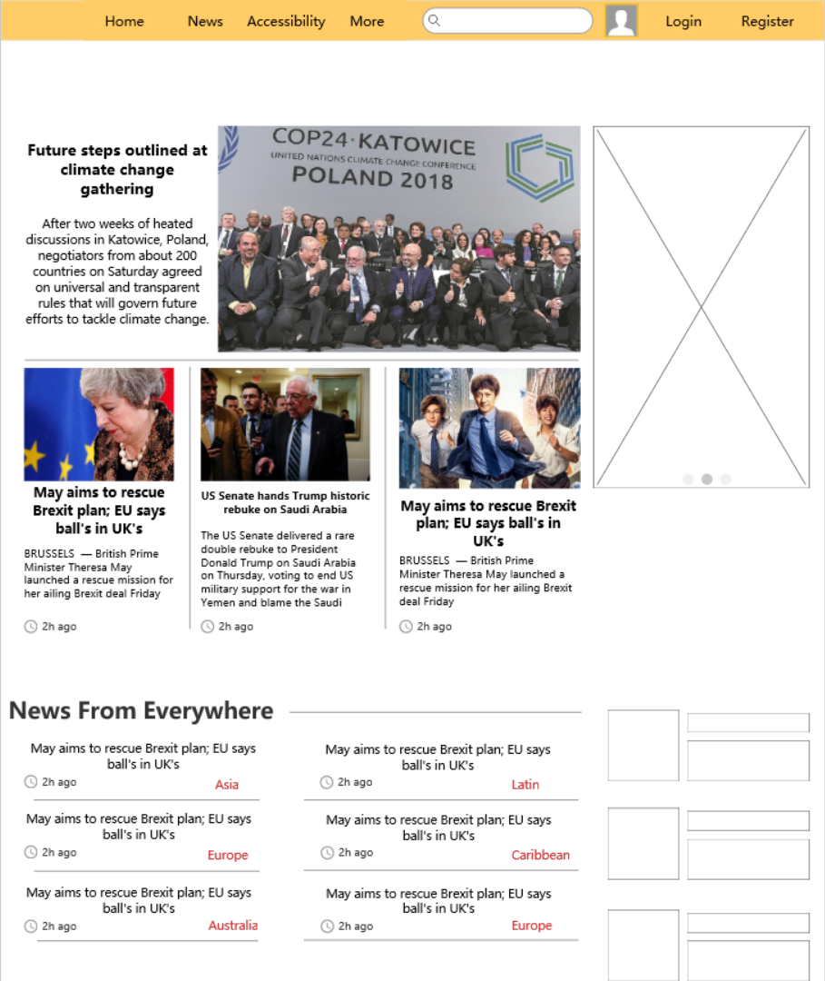

The world news page, showing the news worldwide.

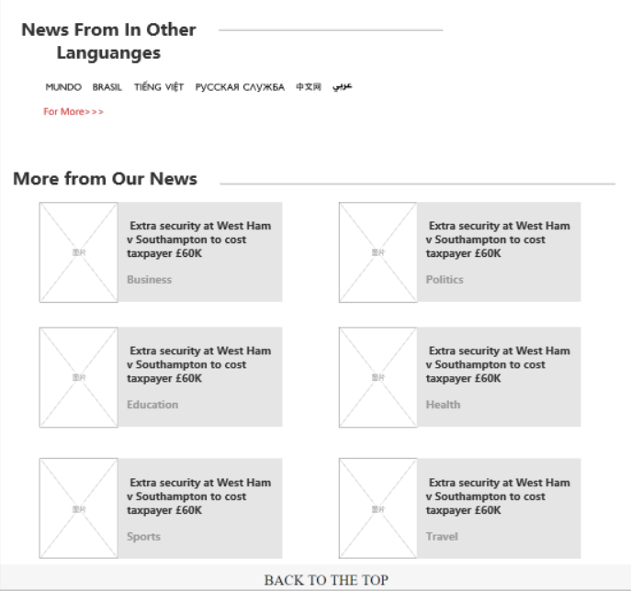

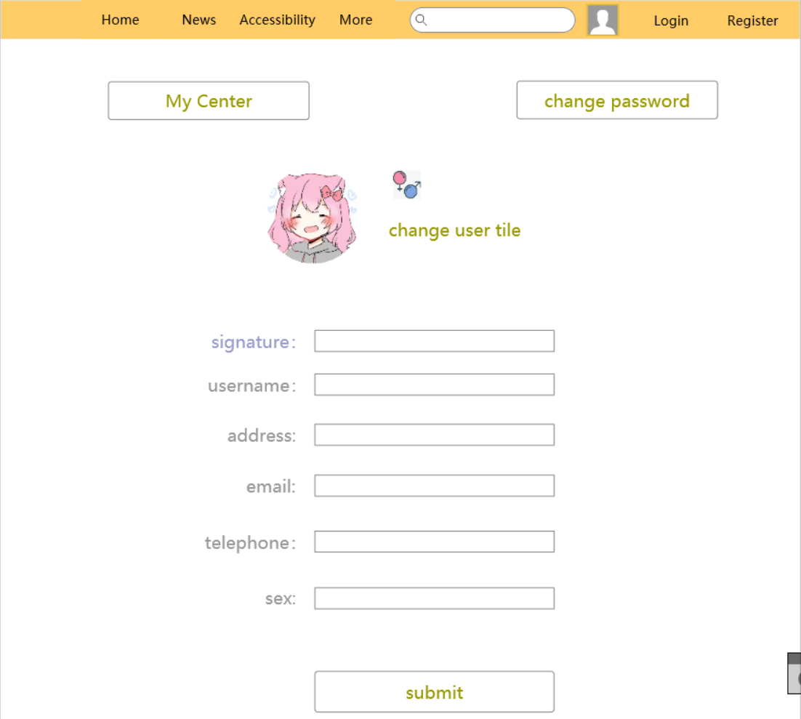

Changing the information. Change the password or some profile information.

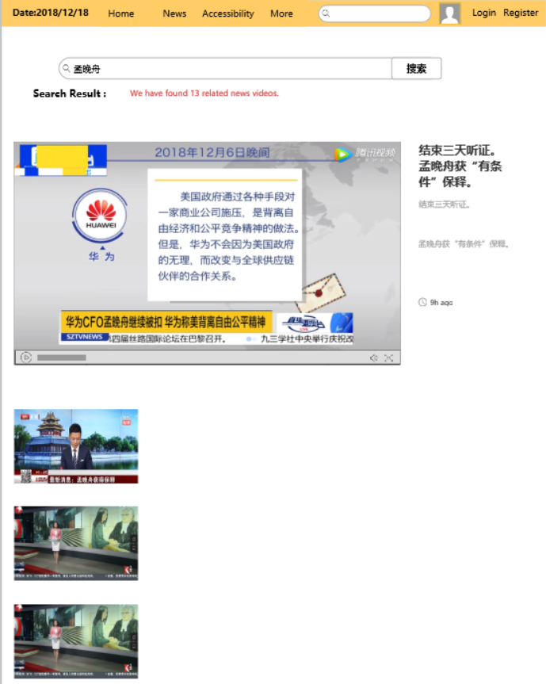

The searching page for searching the key words.

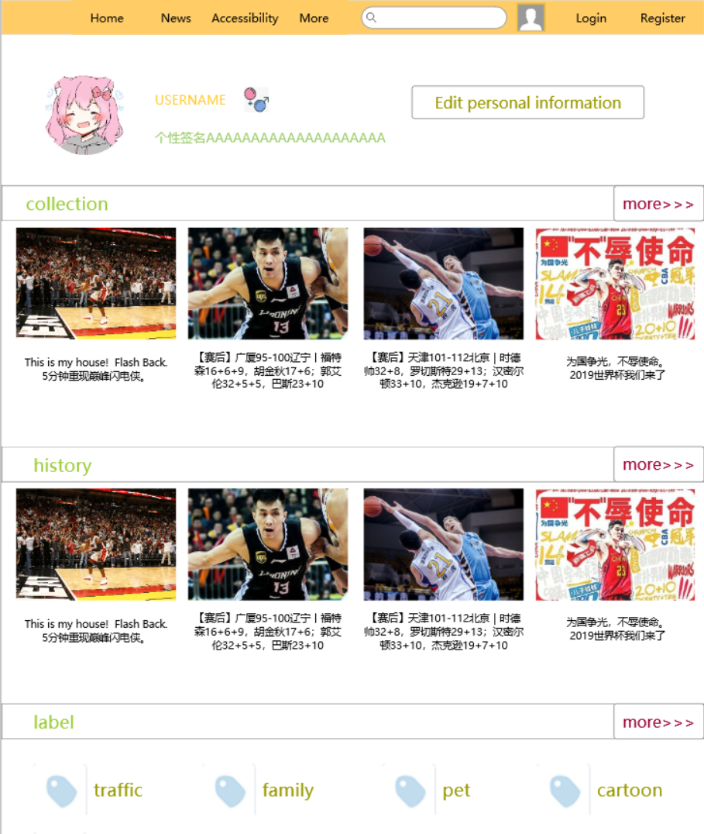

User’s personal center.

Showing user’s collection of favorite news or the publisher he is following.

Also the history of this account.

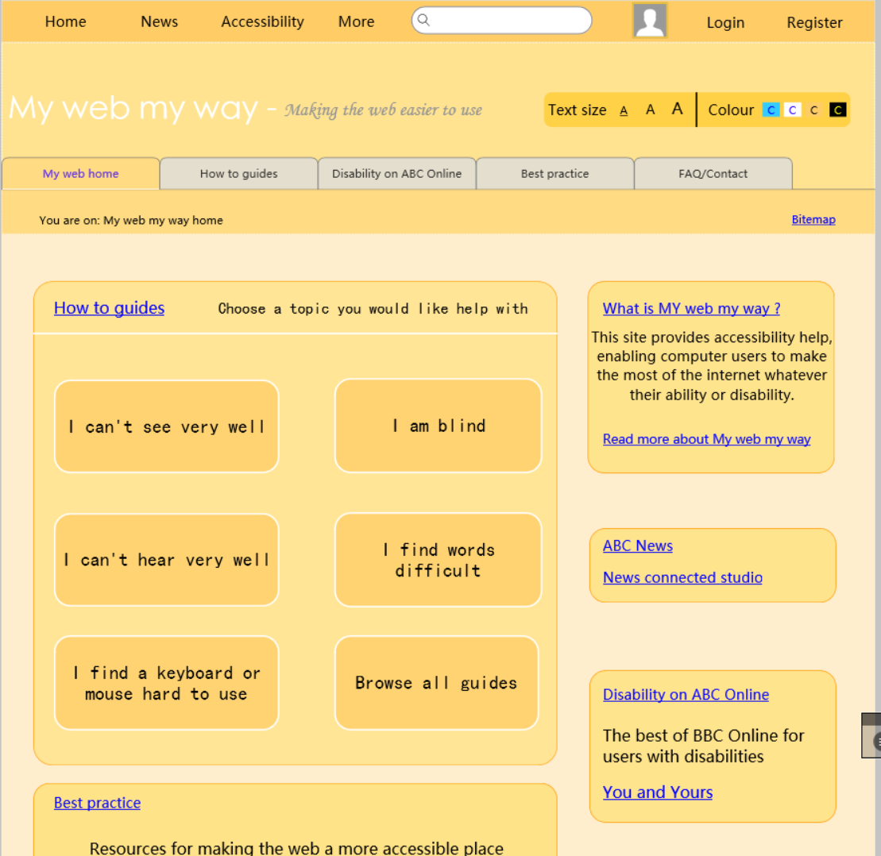

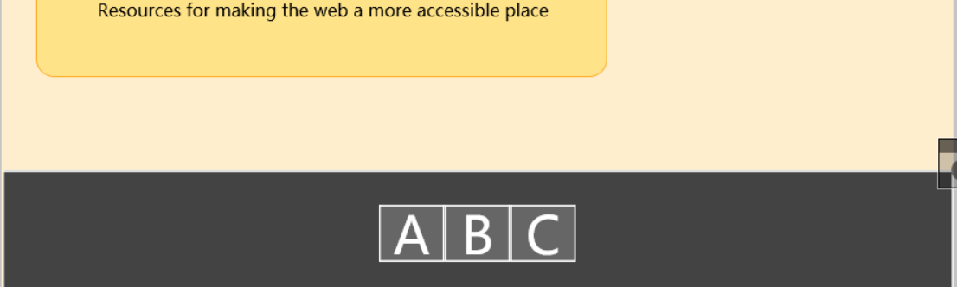

The Accessibility page for all the users who have some problems in using the website.

Can’t see the words correctly? Can’t understand the language in the web page?

Can’t verify the color of the pages?

We could provide a comprehensive center for user to customize his own reading experience.

This is the page for guiding.

# Hierarchical Task Analysis

## Task analysis

Analyze task 1 🡪 Subscribe the publisher and see all the collections of himself

1. Subscribe the publisher and see all the collections of himself
2. Get to the video playing page the user is interested in.
   1. Browse the popular news he may like
   2. Search the key words for the news.
3. Click the subscribe button to follow.
4. Get to the personal page.
5. Show the collection of the users.

The diagram:

**First 1 , then 2 , 3**

1. Subscribe the publisher and see all the collection.

**Do both 1.1 and 1.2 in any order.**

1. Click the subscribe button to follow.
2. Get to the personal page.
3. Show the collection of the users.
4. Get to the video playing page the user is interested in.
   1. Browse the popular news he may like
   2. Search the key words for the news.

analyze the task 2 🡪 To change the language version

Change the language version of the website

Get to the profile

Log In

Get to the language settings, change the version

Get to the article page, change the version of news

The diagram:

1. Subscribe the publisher and see all the collection.

**Or just 5 to 6, directly change the language.**

**First 1 , then 2 , 3**

**First 2 then 3**

1. Log In
2. Get to the language settings, change the version
3. Get to the personal page.
4. Show the collection of the users.

1. Get to the profile

analyze the task 3 🡪 Find the related user needs

Find the specific news the user offers to know.

Register/Login in.

Browse some hot and popular news in the home page.

Select the specific the news he needs.

Get to the specified category page in the home page.

Choose the news listed in the page.

Search in the search bar on the top right corner.

Select the news he needs

Play the media resources and see the news.

# Evaluation 1

NIELSEN’S USABILITY HEURISTICS

## Visibility of system status

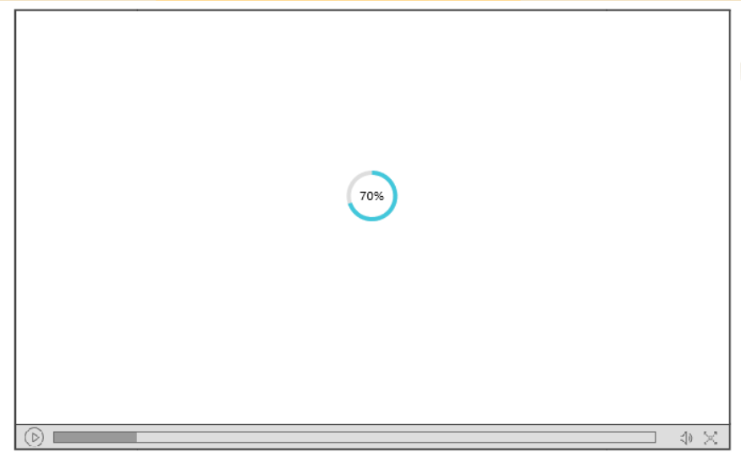

When the player page was loaded, the media player would give a running status reminding the users that the video was keeping loading.

## Match between system and the real world

The web page can provide the user’s language with familiar description. Home, Profile, News etc , these are the words people can know.

## User Control and freedom

Users could choose to sign in or not. But without signing in, they will not enjoy the customized contents.

Then sorry to show that the mistake messages haven’t been designed yet, so we didn’t have the “emergency exit” for now.

We just have the messages for successful operations.

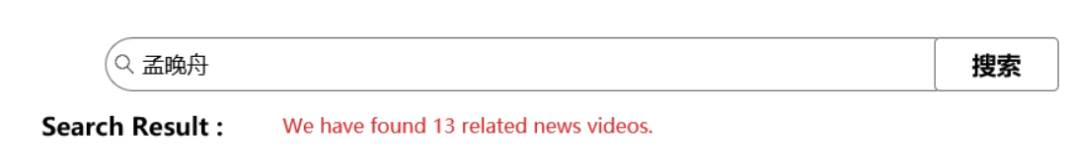

## Consistency and standards





The subscribing button will show the successful actions you have done.

## Error prevention

We will use the specific messages to remind the user what was wrong during the operations.

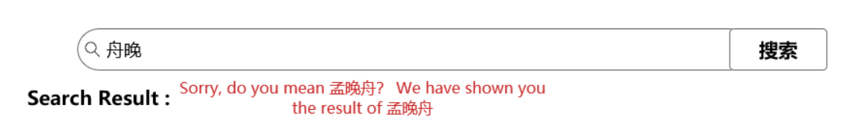

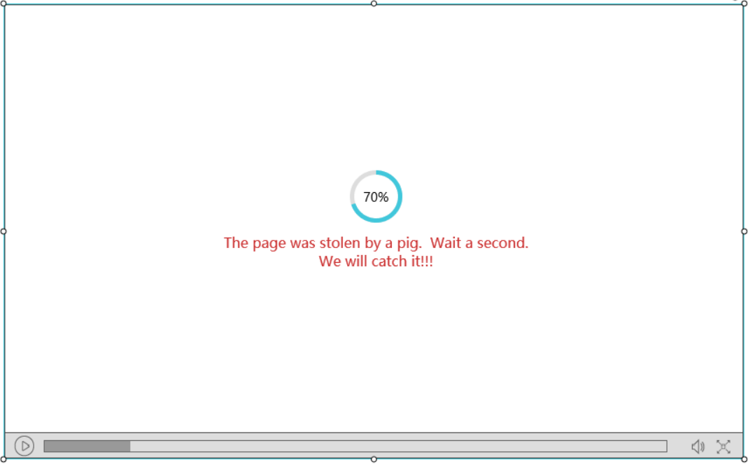

## Recognition rather than recall

For an example , when we enter the search box, the pop-up box will show the recent searched result in a list.

User may get familiar with this, so he won’t enter the content again.

## Flexibility and efficiency of use

All the categories are emphasis on as different color so that the user can know there must be a specific function area.

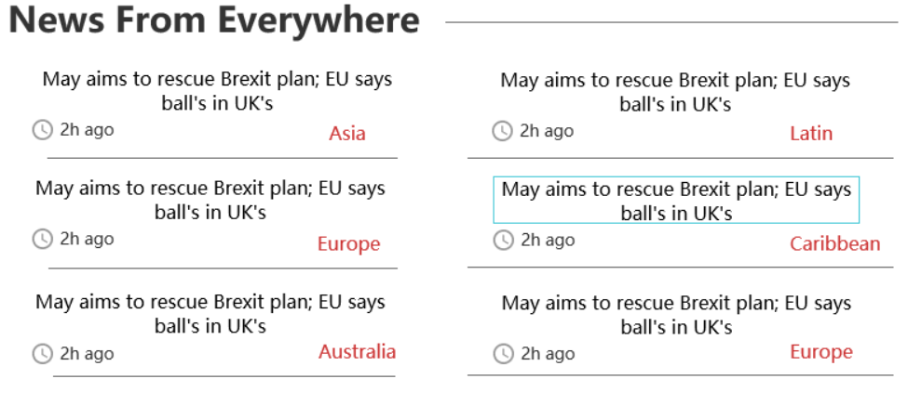

## Aesthetic and minimalist design

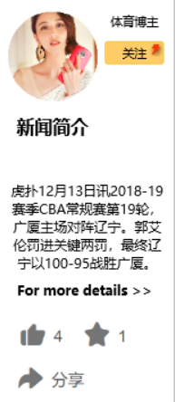We have removed all the irrelevant news users don’t need. And we provide the chances for they to choose, whether to get details or not, depends on themselves.

For more details, then we move to the article details of the news.

## Help users recognize, diagnose and recover from errors

Sorry we put the contents in the step 6, the same as above.

## Help and documentation

Yes we have the helping pages for solving all users’ problem.

It was in our accessibility page.

In this unit user can customize his own reading experience for the web page.

And we have considered the whole situation for the problem solving.

# Evaluation 2

Finally we invited Dong Qing Zhang from the other group, who is my classmates.

I introduced the basic items about our website to him. After a short introduction, he started to test our website design following the task we have given below.

|  |  |  |  |
| --- | --- | --- | --- |
| **Task/Step No** | **Comments** | **Issues** | **Level of Security** |
| 1. The user wants to search the key words for what he wants to watch. | “Oh, you search bar’s color seems so blended in the navigation bar which has the same color;  It was hard to distinguish between them.” | The Search unit doesn’t stand out enough to. | critical |
| 1. The user wants to follow the publisher he gets interested in. | “Oh, I find the *subscribe* button, but I don’t know where I can see the all publisher I have subscribed. Are they all included in the profile pages, oh, finally here it is. I think you’d better remind me a little about it.” | The subscribe button should give a feedback to user about where to see the collections of what he or she likes and get interested in. | Secondary |
| 1. To check the details about the news or posting media. | “The details, is that *for more details.* I find that. But I see that the details are too long, what if the news is short, the comments and the introduction part would be not that tidy and neat as the same with the longer content one.” | The layout for the player interface should be more tidy.  User may get confused about the details news. | Major |

Then we invite HongRong who is also from the other groups, my classmates. He also gives some opinions and the experience about how the project goes.

|  |  |  |  |
| --- | --- | --- | --- |
| **Task/Step No** | **Comments** | **Issues** | **Level of Security** |
| 1. Change the version of language. | I think usually the switch unit is set on the navigation section so that users could directly see the switching function, but yours was set in the profile setting page. So the first time I may feel confused, I have to find the setting. | The setting for switching the languages and the font size supposed to be set in an prominent or well-marked place. Or the people using the other language couldn’t find out easily. | Major |
| 1. Find some news you are interested in. | “I think the color of the news page is a little dark so that I could not verify the category or distinguish between them, yellow and black, I think it was no that good for the color design. You should adjust a little about the layout. | The collocation which means that the color has some problems in matching. You should reduce some color for the user may be some people who are not sensitive with the color. | Major |

Sadly it has been through the delivery time, we actually didn’t adjust all the bad design and modify the system to make it more prefect.

But we have tried to modify all the insufficient situation as soon as possible.

# Things I have learned

For the User Interface Designing the course, I think I have learned a lot about the whole process of designing the interface. All the operations are due to the users, and what I understand is the user-centered. We need to get a complete analyze for the requirements.

Only after figuring out the requirements can we easily get into the interface designing.

What’s more, this course has provided me an experience in designing the interface in an complete project process, a team work. And we should manage the task one after another.

And from the other’s designing, we also learn a lot for the designing part we didn’t make it simple enough, the color or the layout part are still a little complete.

So when comes to the real designing part, we still have a long way to go. The coding, and some other more advanced design, I think we have been motivated enough to do better.